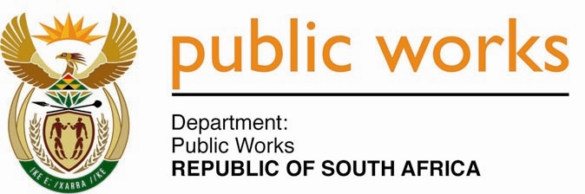

**MINISTRY**

**PUBLIC WORKS AND INFRASTRUCTURE**

**REPUBLIC OF SOUTH AFRICA**

Department of Public Works l Central Government Offices l 256 Madiba Street l Pretoria l Contact: +27 (0)12 406 1627 l Fax: +27 (0)12 323 7573

Private Bag X9155 l CAPE TOWN, 8001 l RSA 4th Floor Parliament Building l 120 Plain Street l CAPE TOWN l Tel: +27 21 402 2219 Fax: +27 21 462 4592

[www.publicworks.gov.za](http://www.publicworks.gov.za)

**NATIONAL ASSEMBLY**

**WRITTEN REPLY**

**QUESTION NUMBER: 419 [NO.** **NW484E]**

**INTERNAL QUESTION PAPER NO.: 01 of 2022**

**DATE OF PUBLICATION: 25 FEBRUARY 2022**

**DATE OF REPLY: MARCH 2022**

**419. Mr. P A van Staden (FF Plus) asked the Minister of Public Works and Infrastructure:**

(1) (a) What total number of the 81 575 properties that are under the custodianship of her department are in arrears with its property tax, (b) what total amount is in arrears and (c) to which municipalities are the arrear amounts due;

(2) whether she will make a statement on the matter? **NW484E**

**_______________________________________________________________________________**

**REPLY:**

**The Minister of Public Works and Infrastructure**

1. As per the age analysis submitted by 145 municipalities to DWPI for the month ending 31 January 2022, there were a total of 10 483 accounts with arrear balances. The total outstanding arrears amount on property rates as per age analysis from the municipalities was R611 million.

DPWI has further analysed the age analysis and the account to confirm the accuracy of the reported amounts. The breakdown of the R611 million is categorised as follows:

|  |  |
| --- | --- |
| **Debt Category** | **Sum of Sum of Outstanding Amount: Property Rates** |
| Bills not yet received from municipalities | R 885 577.19 |
| Billed annually by municipalities but not yet due from the department | R 35 148 971.50 |
| Disputes over property ownership & custodianships, incorrect billing, interest charged, etc. | R 24 917 7726.82 |
| Payment rejected due to change of municipal bank account | R 3 304 720.98 |
| Payments not allocated by municipality | R 383 340 408.43 |
| Reconciliations in progress with municipalities | R 40 503 948.83 |
| State Domestic Facilities (and ITB Properties) | R 123 246 849.05 |
| **Grand Total** | **R 611 348 202.80** |

Based on the above, DPWI can confirm that only R76 million billed by the municipality is outstanding as per the age analysis of the municipality but not yet due and payable by DPWI. DPWI does not pay annual property rates in advance but pay them programmatically on a monthly basis. While municipalities may be reflecting the annual property rates as due and payable, and invariably overdue, there are few instances where invoices are not paid within 30 days.

1. DPWI processes all valid invoices received within the stipulated timeframe indicated by municipalities since their invoices are due and payable below the regulated 30 days of receipt of invoice. Notwithstanding the above mentioned, DWPI has made payments across all 257 municipalities to the value of R1.8 billion (March 2021: R1.3 billion). This is a clear demonstration and continuous endeavours by DPWI to ensure that all valid invoices from municipalities – as it is with other creditors – are settled timeously however there are few instances where invoices are not paid within 30 days.